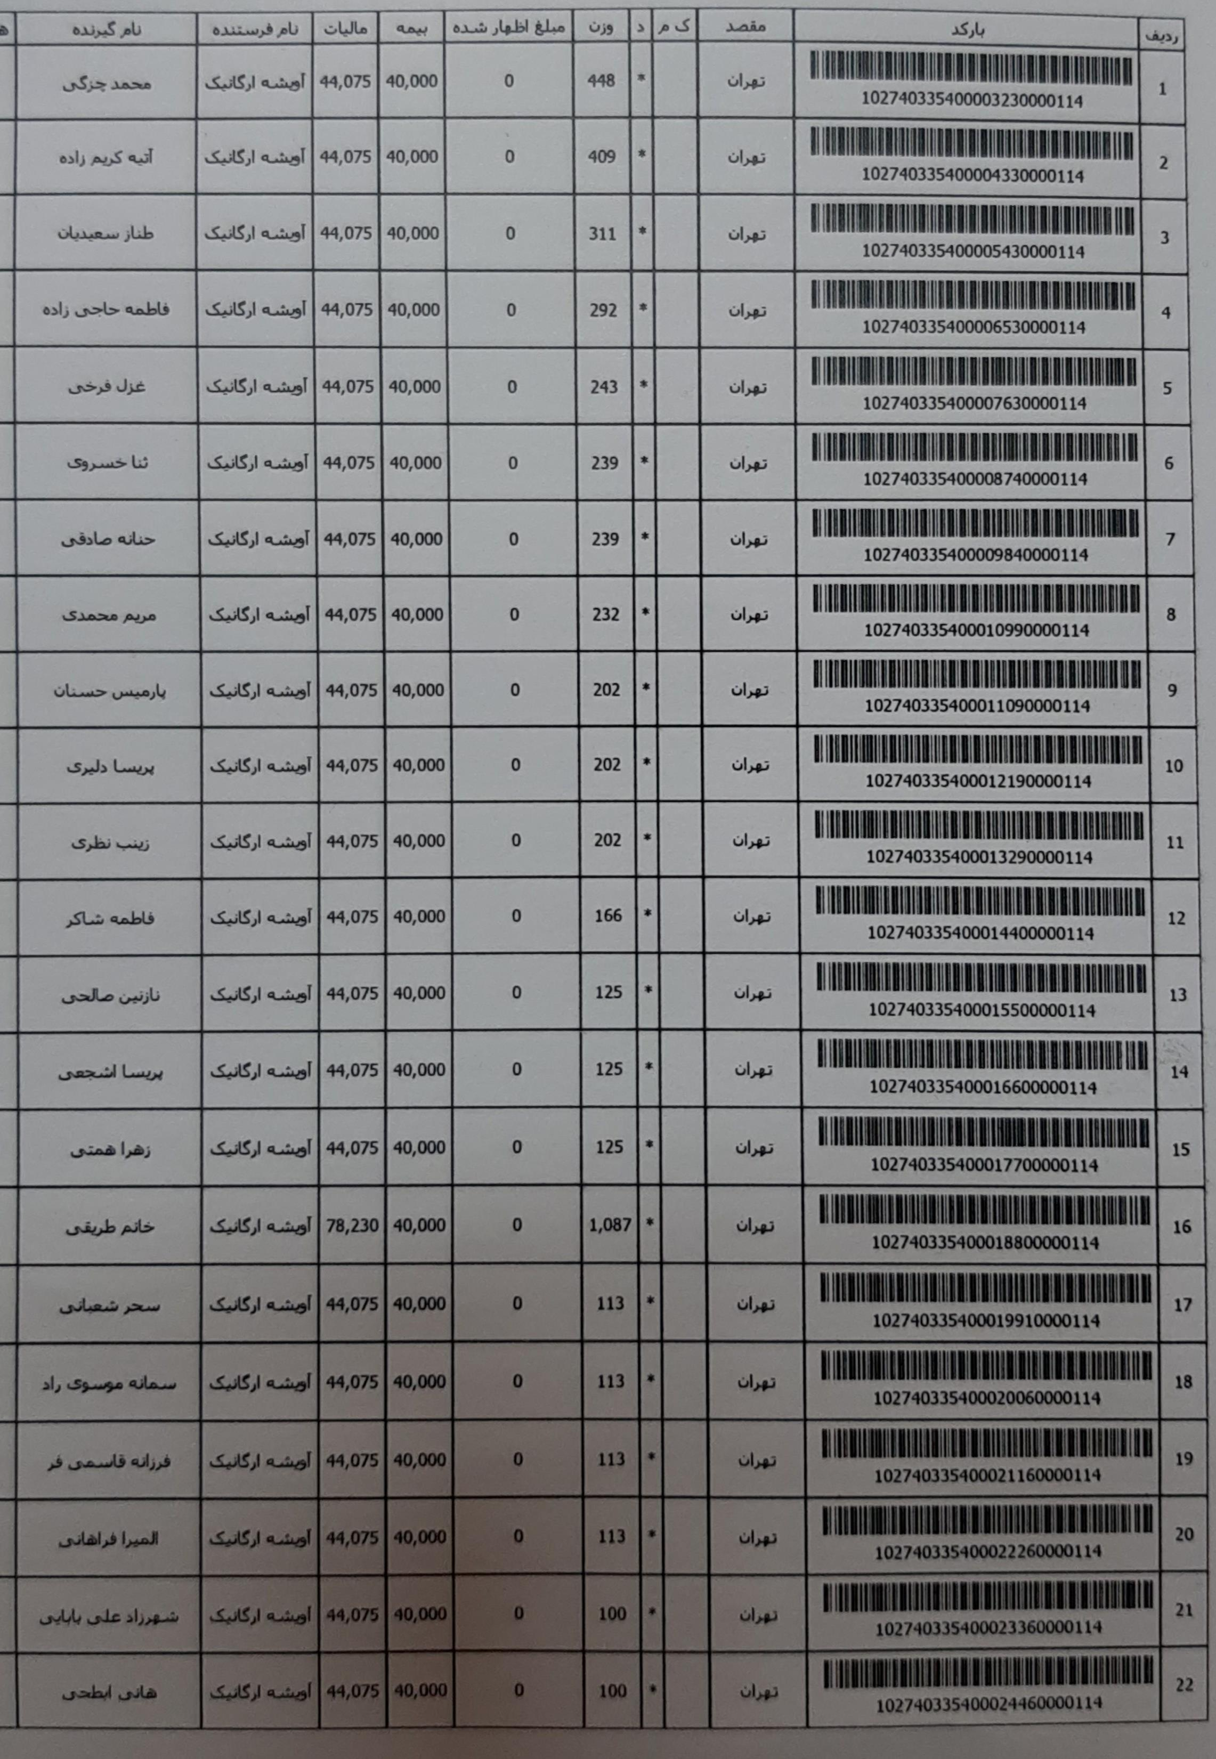­­­­­­­­­­­­­­

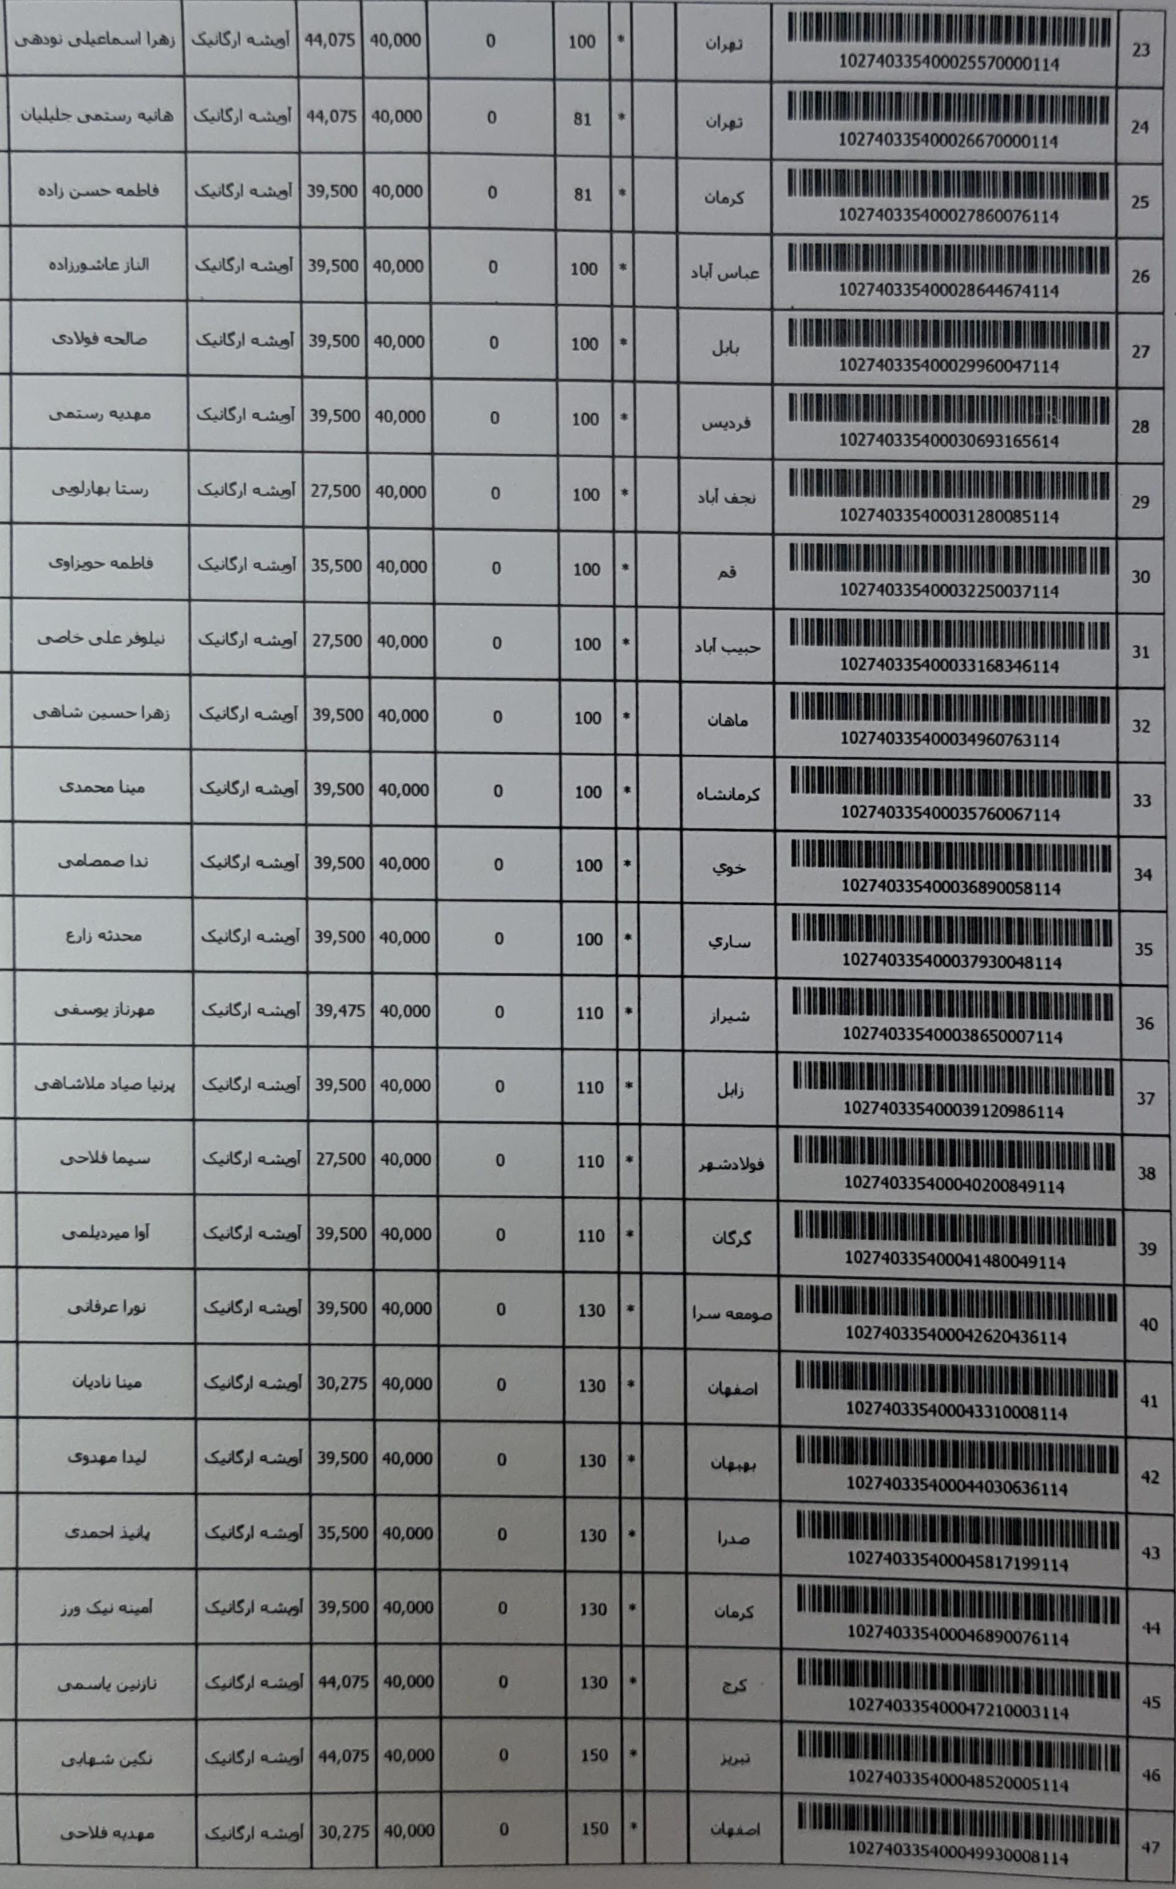

0 150 48

102740335400050450077114

0 150 49

102740335400051300499114

0 150 so

102740335400052330758114

0 150

102740335400053180006114

51

0 157 •

•A g.i 4. A

•

1027403354000545

114

52

<US,/ etl 35,500 40,000 0 157 + **53**

102740335400055790038114

US,/ ±sl 35,500 40,000 0 178 54

102740335400056957576114

US,l eAel 35,500 40,000 0 185 + **55**

102740335400057810739114

*<US,/* e4es] 39,500 40,000 0 205 56

102740335400058187737114

*es,Us* el Sl «ts] 39,500 40,000 0 205 + la. 57

### 102740335400059100065114

US,/ etosl 44,075 40,000 0

219 +

1027403

### 114

**58**

0 243 + **59**

10274033!: **061138454114**

0 253 +

### 102740335400062610986114

**60**

<US,/ e l

3 0,275 40,000 0 260 . • I **61**

### 102740335400063450008114

0 289 +

10274033

! I I

### 550008114

**62**

*<1SJ* <±el 39,500 40,000 0 292 + 63

**102740335400065959943114**

# <US,] els] 39,500 40,000 0

296

10274033

1 **114**

64

US,] <Al 39,500 40,000 0 303 + eta, 65

10274033! **7130076114**

*why>>* L *l* .UJ eel 39,500 40,000 0 310 + **66**

10274033: **3114**

Sa a. >

0 330 +

•

'l l'

' .

10274033! **1478143114**

67

'' ' '

] I '

I

<US/ <es] 35,500 40,000 0

397 •

l

I • I

' I

d

I I I I I

•

I I

ll

'

'

'

**68**

1027403354( **8386114**

# <U,1 <ts] 39,500 40,000 0

351 +

10274033

## 7114

**69**

10274033

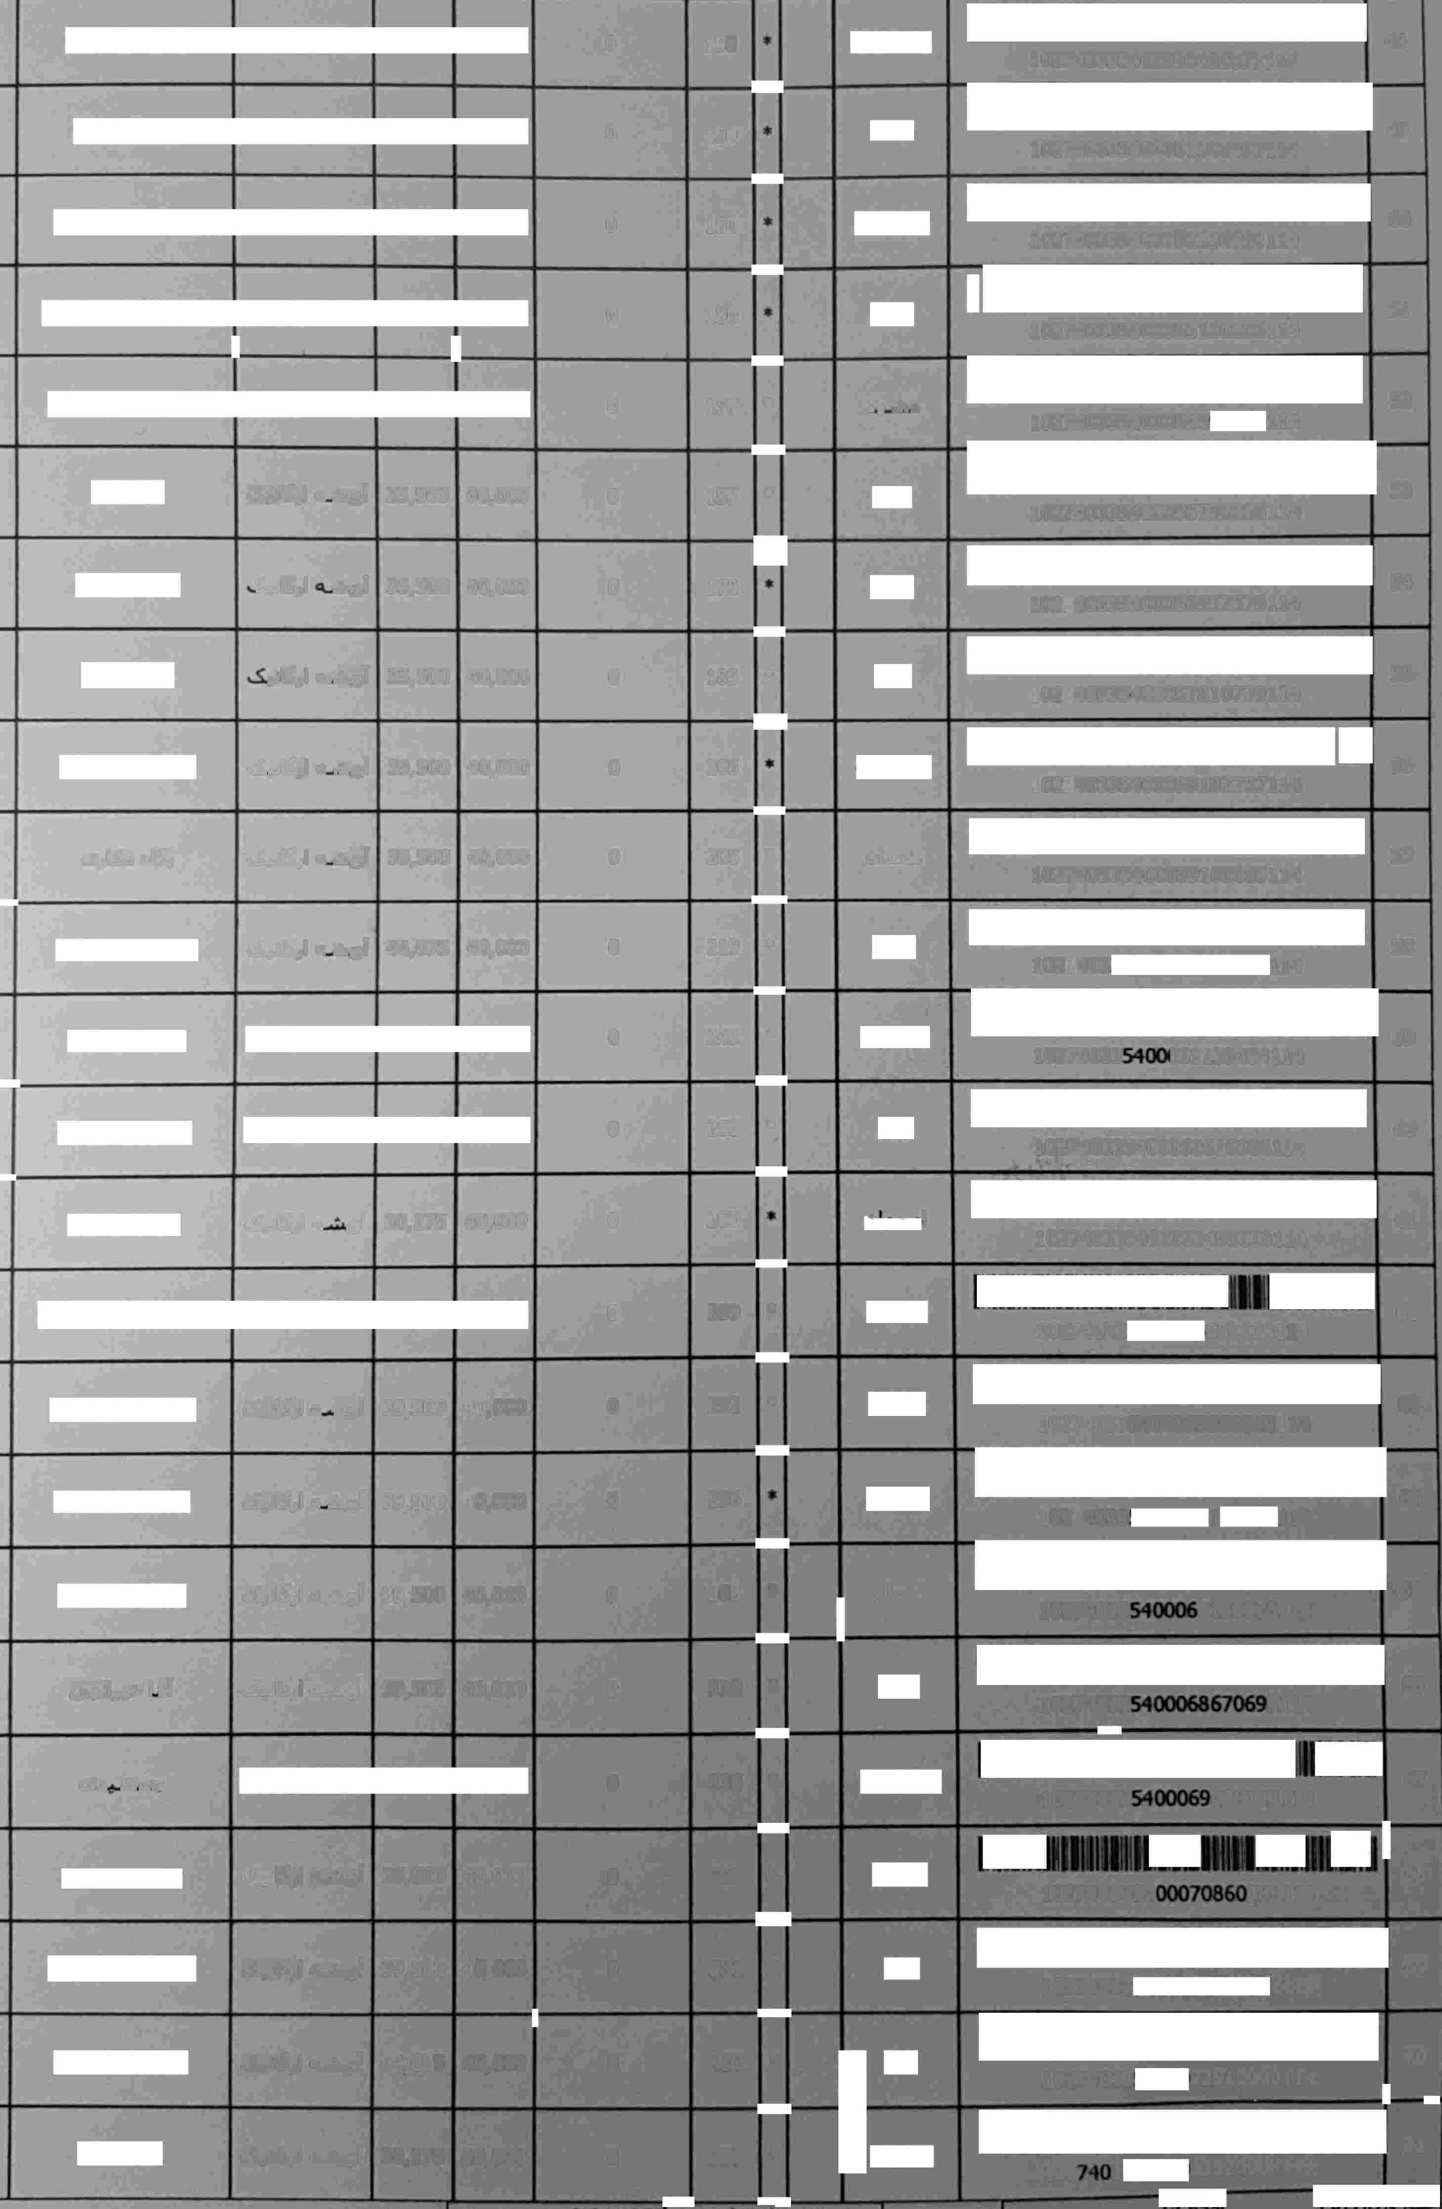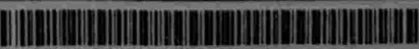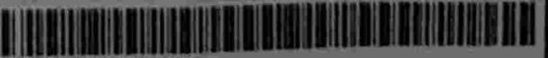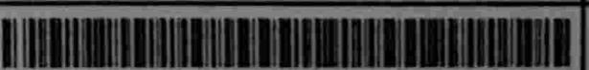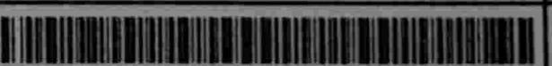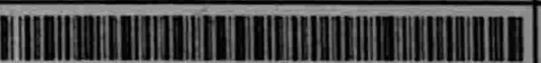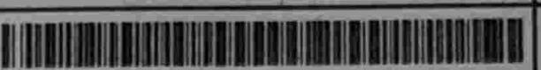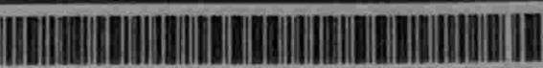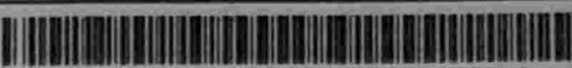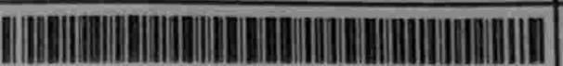

|  |  |  |  |  |  |  |
| --- | --- | --- | --- | --- | --- | --- |
| *<US,J* et3l | 4,075 | 40,000 | 0 | **420** | **•** |  |
| SU,l <Al | 30,275 | 40,000 | 0 | 927 | • | • |



102 83

## 72910003114

•

73520008114

70

71